𝙷𝚊𝚙𝚙𝚢 𝙱𝚒𝚛𝚝𝚑𝚍𝚊𝚢 Ⴝ𝖆𝚌𝚑ín



# Slice of Birthday CakePresent𝙷𝚊𝚙𝚙𝚢 𝙱𝚒𝚛𝚝𝚑𝚍𝚊𝚢 Ⴝ𝖆𝚌𝚑ín

# **Cheers to the man of the hour! Happy birthday,hope it’s a great one…**

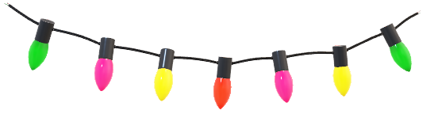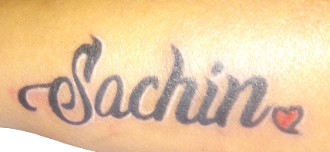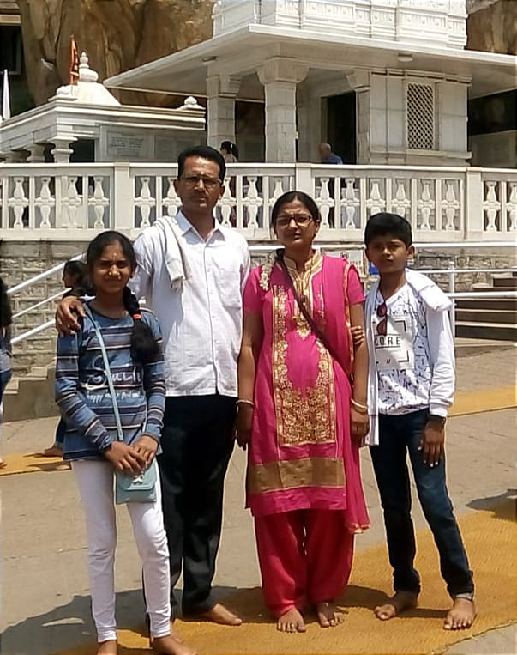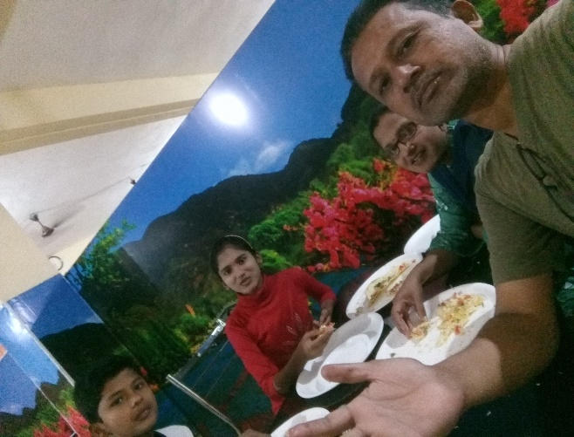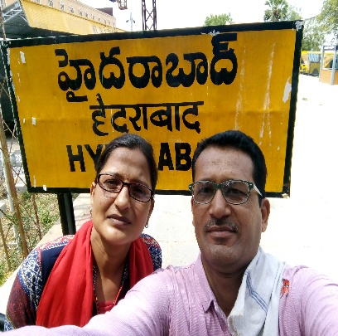

**Here’s to celebrating you, Dad ,today and always . Cheers to another year of making beautiful memories together.You’re not just a year older, you’re a year wiser, and I cherish every lesson you’ve taught me…**

